**In-Class Exercise # 7 – “Start Assembly Programming”**

Due Day: 2017/03/30, Friday, 12:00

Objective: To understand how to use MUL instruction in a simple Assembly program and program structure.

Explanations：

1. Use the course content to learn data in memory storage and how to use MUL instruction. Make a program that stored multiplication table from 1*1 to 9*9 as shown as in the memory.

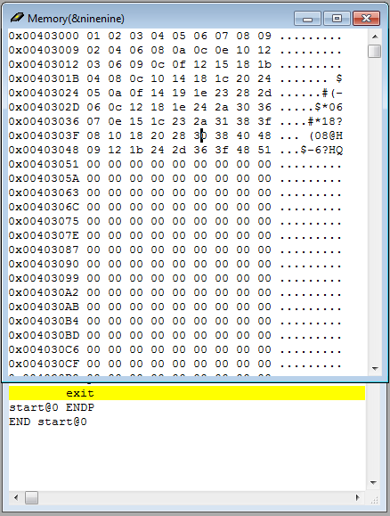

|  |
| --- |
| .data  ninenine byte 81 DUP(?)  .code  start@0 PROC    [do something...]    exit  start@0 ENDP  END start@0 |

1. Use WINdbg to shows registers and memory status when program executed and add screenshots to report in Word files.
2. Compress(.zip,.rar) the following file with the name of the group ( e.g. group_1.zip)
   * 1. Code(**exercise7.asm**)
     2. Report(**group_1**.doc/.docx or **group_1**.pdf)
        1. Report Title
        2. Group, name, student ID
        3. Program execution flow, memory (register) status
        4. Screenshots description code Description
        5. Reviews
3. To update the contents of report can be directly re-upload file with the name of version (e.g. Group_1_v2.zip)

Note：

1. Each group, one report
2. Upload the report to (<http://lms.ncu.edu.tw/ncu>) before Friday, 12:00.